house of muchness
artistic practices for the creative wellbeing of young people

Summer Studio – Riddells Creek, 3-7 January 2018

Enrolment Form

Name:

Birthdate, age and 2018 school grade:

Street address:

School:

Parent/Carer phone:

Participant phone:

Parent/Carer email:

Participant email:

Gender (please circle): Male/Female/Other gender identity

Medical condition or medications:

Access need/s:

Food allergies and dietary requirements:

What is your cultural background?

Do you give permission for your child’s image to be used in public for the House of Muchness? eg social media promotion? (includes audio recordings and creative contributions)

How did you hear about House of Muchness?

Payment by bank transfer only.

Bank details
Account Name: House of Muchness
BSB: 013445
Account Number: 296829386
Description to recipient: Child first initial and last name, last two digits of year and term/holiday abbreviation eg AWalker17T1 or AWalker17Sum

We can’t wait to have you join us!

alex walker
director, house of muchness
ph: 0413 994 428
e: info@houseofmuchness.com

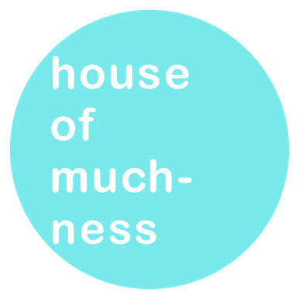

LONGER RESPONSE
(participants to complete)

The more we know about you as a young artist, the way you like to learn and work and create, the more we can ensure this experience is custom designed.

What parts of art-making and performance interest and excite you?

Are there parts of art-making and performance that you avoid, find boring, disengage from? If so, which? Eg line-learning, solo work

Aside from theatre-making, what other skills are you working on? Eg musical instruments, visual arts, languages

How do you learn the best? Eg in short chunks, in groups, with music

What other types of activities do you like or dislike? eg hate singing, love hiking

Please add any other information that will help us create the best time for you!

